**AI-Based Diabetes Prediction System**

**Importing Libraries**

In the initial phase of our project, we begin by importing the necessary Python libraries that play a pivotal role in building our AI-based diabetes prediction system. These libraries enable us to handle data, create and train machine learning models, evaluate model performance, visualize results, and save our model for future use. Let's briefly introduce the libraries we're using:

* **Pandas:** We utilize the Pandas library to manage and manipulate our data effectively. Pandas provides powerful data structures like DataFrames, which allow us to organize, clean, and explore our dataset.
* **Scikit-Learn (sklearn):** Scikit-Learn is a comprehensive machine learning library that offers tools for data preprocessing, model selection, training, and evaluation. In our project, we make use of Scikit-Learn's functions for data splitting, creating a decision tree model, and calculating accuracy.
* **Matplotlib:** Matplotlib is a versatile library that facilitates data visualization. It helps us generate visual representations of our model's decision tree, making it easier to understand and interpret.
* **Joblib:** Joblib serves as our solution for saving and loading machine learning models. It enables us to store our trained model as a file, making it readily accessible for making predictions without retraining.

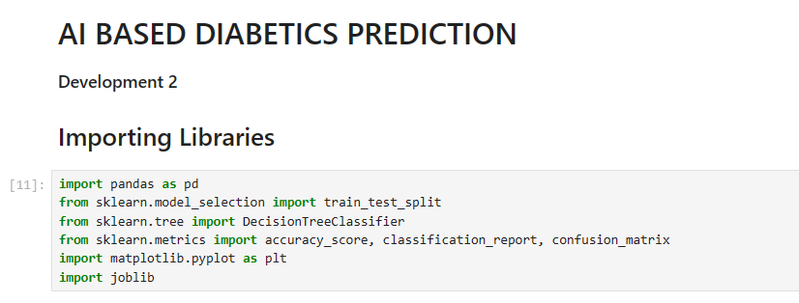

**Loading Preprocessed Data**

Our AI-based diabetes prediction system relies on high-quality data to function effectively. In this section, we load our preprocessed data from a CSV file. The preprocessed dataset is crucial because it ensures that the data used for training and testing our model is clean, structured, and ready for analysis.

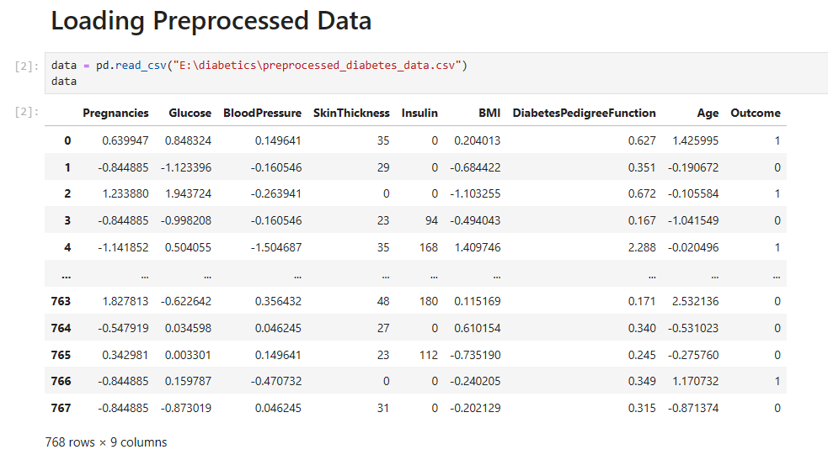

**Splitting the Data**

To evaluate our machine learning model's performance, we need to divide our dataset into two parts: a training set and a testing set. We accomplish this by using the `train_test_split` function from Scikit-Learn. An 80-20 split ratio is commonly employed, where 80% of the data is used for training, and 20% is reserved for testing. This segregation allows us to train the model on one portion and evaluate it on unseen data.

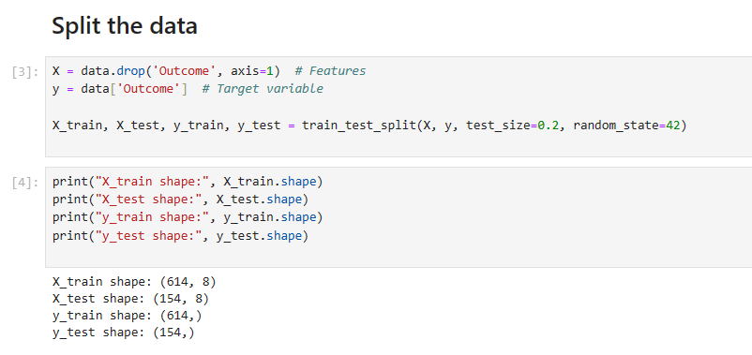

**Training the Decision Model**

Our AI system is the Decision Tree model. Decision Trees are intuitive and interpretable models that can make predictions based on the values of input features. We create and train our Decision Tree model using the Scikit-Learn's `DecisionTreeClassifier`. The training process equips the model with the ability to make informed predictions.

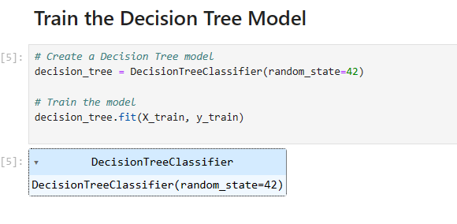

**Evaluating the Model**

Evaluating our model is a critical step in determining its effectiveness. We use various evaluation metrics to assess its performance. These metrics include accuracy, precision, recall, F1 score, and ROC AUC. The evaluation process helps us understand the model's strengths and weaknesses.

* **Calculating the Accuracy:**Accuracy is a fundamental evaluation metric that quantifies the model's ability to make correct predictions. It is calculated by comparing the model's predictions with the actual outcomes in the testing data. While accuracy is essential, especially for balanced datasets, it's not the sole metric used for assessing our model's performance.

